Delivery time dataset

- Imported the dataset, and performed EDA.
- Then plotted scattered plot between input and ouput to find relation between then, plot is below
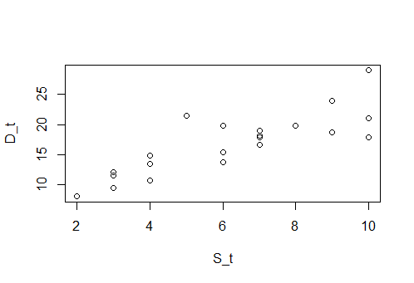
- Then fomed several model to find out the best one
- Model_3 is the best one among all as it is providing best R^2 value and rmse.
- model.1 - D_t= 6.5827+1.6490(S_t), r=0.8259973, R^2=0.6823, rmse=2.79165

- lwr=2.979134+1.108673(S_t)
- upr=10.186334+2.189367(S_t)

- model.2- D_t=1.160+9.043log(S_t), r=0.8339325, R^2=0.6954, rmse= 2.733171(better model)

- model.3- log(D_t)=2.12137+0.10555S_t, r=0.8431773, R^2=0.7109, rmse=3.377184 (best one)

